MRU / SOE/ CSE/ R-22 / MR22-1CS0141/2023-2024

# Assignment Test- 4

**Subject : DAA/ MR22-1CS0141**

# Submission Dates : 12-12-2023 to 18-12-2023

1. Explain the General method of Dynamic Programming- Principle of Optimality and Applications of Dynamic Programming.
2. What is purging or dominance rule. Obtain the solution vector for the given 0/1 knapsack instance: n=4, pi= { 1,2,5,6 } , wi = { 2,3,4,5} and m=8.
3. Solve the 0/1 Knapsack problem for the given n=4, m=5 and w[i] = {2, 3, 1, 4} and p[i] = {4, 5, 3, 7} using Tabulation method.
4. Apply Floyd Warshalls Algorithm to find shortest path between all the pairs for the given directed graph.

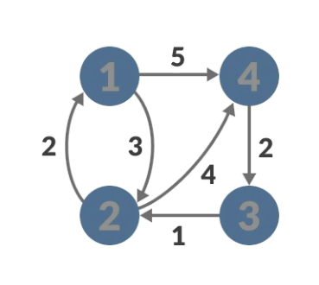

1. Estimate the least cost route for Travelling sales person problem using dynamic programming by considering the given distance matrix:

|  |  |  |  |  |
| --- | --- | --- | --- | --- |
| **–** | **24** | **11** | **10** | **9** |
| **8** | **–** | **2** | **5** | **11** |
| **26** | **12** | **–** | **8** | **7** |
| **11** | **23** | **24** | **–** | **6** |
| **5** | **4** | **8** | **11** | **–** |
|  |  |  |  |  |

1. Consider A1 = 4 x 10, A2 = 10 x 3, A3 = 3 x 12, A4 = 12 x 20, A5 = 20 x 7 and apply matrix chain multiplication to obtain optimal sequence.
2. Differentiate between dynamic programming and branch & bound algorithm design technique.